COR Men's Gathering  Mary: A Biblical Walk with the  Blessed Mother  Session 5  The Presentation and  Finding Jesus in the Temple  Saturday October 24, 2026  9:00–10:30 AM  St. Clement Education Center • Rooms 2A–2B  “And his mother kept all these words in her heart.”  Luke 2:51 • Douay-Rheims | 
Today's Theme
Mary teaches us to obey God, remain faithful through sorrow, and seek Jesus when His ways are difficult to understand.
Our Mission
To encounter Jesus Christ, grow in authentic Catholic brotherhood, and become the men God has called us to be.
Agenda
9:00 AM – Welcome, Opening Prayer and Review
9:10 AM – Scripture Reading
Luke 2:22–35 and 2:41–52
9:18 AM – Ascension Video
Mary: A Biblical Walk with the Blessed Mother
Session 5 – Both video parts, about 20 minutes
9:39 AM – Group Discussion
We'll reflect on questions such as:
- What did the Holy Family’s obedience and humble offering reveal?
- What does Simeon’s prophecy teach us about Mary and the Cross?
- How can we seek Jesus faithfully when we do not understand?
- What does Jesus’ devotion to His Father ask of us?
- Where is God asking you to remain faithful this week?
10:05 AM – Fraternity, Small Groups and Intercessions
10:15 AM – Marian Heritage: The Angelus
Its meaning, daily practice and prayer together
10:25 AM – Commitment and Closing Prayer • Conclude at 10:30 AM

Living This Week’s Lesson
Choose one concern to entrust to God each day, and ask:
“Lord Jesus, teach me to seek You, accept the Father’s will, and remain faithful when I cannot see the way.”
Then take one concrete step to:
- Pray the Angelus at noon; build toward morning, noon and evening.
- Read Luke 2:22–35 or 2:41–52 slowly and ponder one verse.
- Meditate on the Presentation or Finding in the Temple while praying a decade of the Rosary.
- Support someone carrying a sorrow through prayer and practical help.
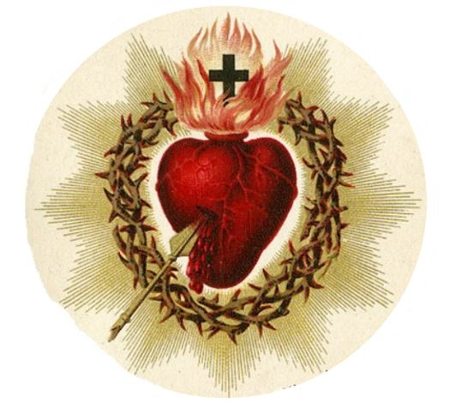 | Looking Ahead  Next COR Gathering: To Be Announced  Bring a friend. Every man is welcome.  Pray for one another. Invite another man to join us.
For Reflection This Week
“Lord Jesus, give me a faithful heart in my duties, patience in uncertainty, and courage to stay close to You.”
Mary’s yes at the Annunciation continues through the Temple and the Cross.
COR Takeaway
A Catholic man seeks Christ faithfully, offers his duties to the Father, and stands beside those who suffer.

