COR Men's Gathering  Mary: A Biblical Walk with the  Blessed Mother  Session 4 – The Nativity  9:00–10:30 AM | 

“And she gave birth to her firstborn son and wrapped him in swaddling cloths, and laid him in a manger.”
Luke 2:7
Today's Theme
God works through disruption and humility; Mary receives, ponders, and bears the true Savior into the world.
Our Mission
To encounter Jesus Christ, grow in authentic Catholic brotherhood, and become the men God has called us to be.
Agenda
9:00 AM – Welcome & Opening Prayer
9:10 AM – Scripture Reading
Luke 2:1–20 – The Nativity
9:15 AM – Ascension Press Video
Mary: A Biblical Walk with the Blessed Mother
Session 4 – The Nativity (about 16 minutes)
9:35 AM – Group Discussion
We'll reflect on questions such as:
- What stood out to you most from today’s video?
- Where can you see God’s providence at work in an unwanted disruption?
- What does Mary teach us by keeping and pondering these things in her heart?
- What do the manger and the Cross reveal about Jesus’ kingship and humility?
- How can you bear Christ into your home, work, or friendships after receiving him in the Eucharist?
10:05 AM – Fraternity, small-group discussion and prayer.
10:15 AM – Marian Doctrine: “Firstborn,” “Brothers,” and Mary’s Perpetual Virginity
10:25 AM – Wrap-Up & Closing Prayer

Living This Week's Lesson
Each day this week, bring one disruption or disappointment to God and ask:
“Lord, what are You trying to show me? How are You asking me to grow in patience, compassion, humility, or trust?”
Then take one concrete step to:
- Spend two quiet minutes with Jesus after Holy Communion.
- Ponder one verse from Luke 2:1–20.
- Choose humble service over recognition.
- Bear Christ to one person through kindness, truth, or practical help.
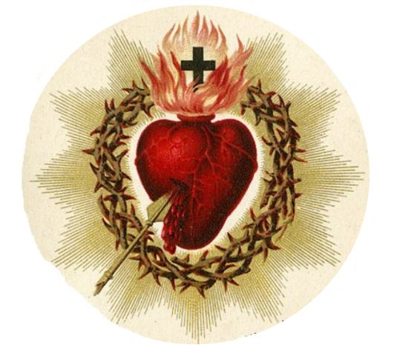 | Looking Ahead  Next COR Gathering: To Be Announced  Bring a friend. Every man is welcome.  “Glory to God in the highest, and on earth peace.” — Luke 2:14
For Reflection This Week
“Lord Jesus, help me receive You humbly, ponder Your word faithfully, and carry Your peace to others.”
“Mary kept all these things, pondering them in her heart.” (Luke 2:19)
COR Takeaway
A Catholic man receives Christ humbly, keeps His word in his heart, and bears His presence into the world.

