50th Anniversary Celebration of
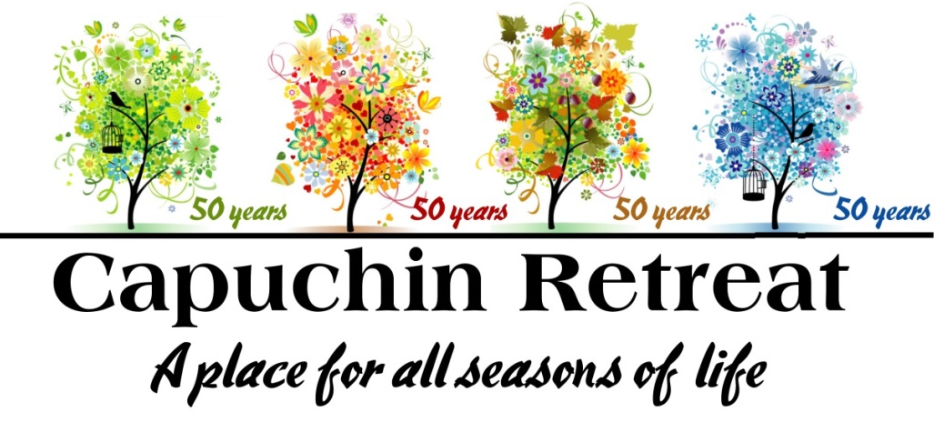

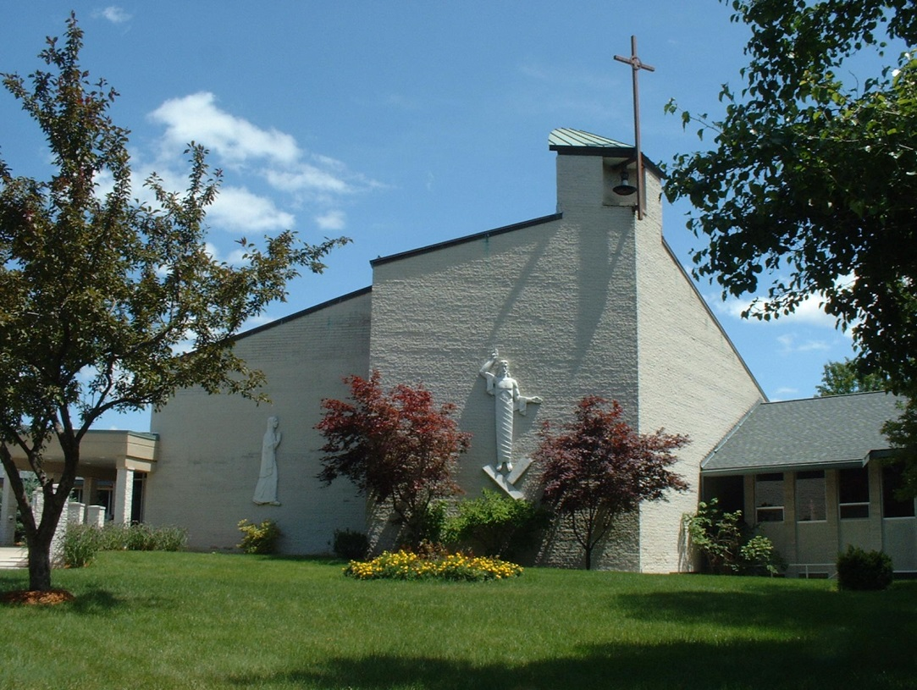

Sunday, July 15, 2018 1pm to 5pm
62460 Mt. Vernon Rd, Washington, MI 48094
Phone: 248-651-4826 info@capretreat.org
Parking is available at SS John & Paul Catholic Church, Washington, MI
with continuous shuttle service to and from the Retreat Center

Purpose of the Capuchin Retreat
….A Beautiful Place to Pray

Capuchin Retreat is rooted in the Franciscan tradition of hospitality, simplicity and Christian values. We welcome people of all faiths. We provide a place of renewal and relaxation for individuals and groups. The center offers an opportunity for solitude and peace, and escape from our hectic lives.

- 95 acres of gentle meadows with a pond and walking paths
- 47 bedrooms with lounge chair and private bath with shower
- Beautiful chapel and lounge with a fireplace
- Library with spiritual CDs and books
- Gift shop
- Conference rooms for group meetings
- Full dining service

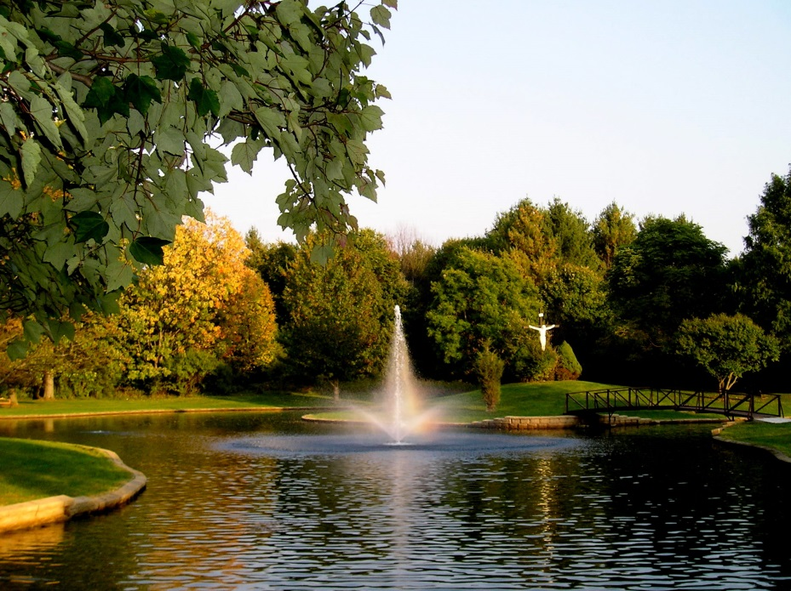

It would be difficult not to discover peace of mind and a quiet heart in the charm which surrounds Capuchin Retreat. Deer, wild turkey, along with numerous birds and wild flowers decorate the open fields and wooded areas along the many paths that wind through the 95 acres of unspoiled beauty.
For a time to relax we can put aside our cell phones, daily chores, work, meetings, and various daily commitments to slow down, resting the body and spirit. This time enables us to meditate and listen to the silence and fill our inner selves with our God. A weekend retreat, evening of prayer or ‘some time away’ provides an opportunity to deepen our relationship with God and find the strength to face the challenges of Christian living with renewed hope and determination.
Bordering Stoney Creek Nature Center, Capuchin Retreat offers an ideal atmosphere of relaxation and beauty. The Capuchin Friars and Extended Preaching Staff present weekend retreats and are available for directed retreats and spiritual direction. We welcome private and directed retreats for small groups or individuals. The center is also available for hosting of groups who wish to run their own programs.
We invite you to celebrate this 50 Year Milestone with us. Bring your family for a picnic-style open house Celebration on Sunday, July 15, 2018 from 1pm to 5pm (rain or shine). Parking is available at SS John & Paul Catholic church, 7777 28 Mile Rd., Washington, MI with continuous shuttle service to and from the Retreat Center.

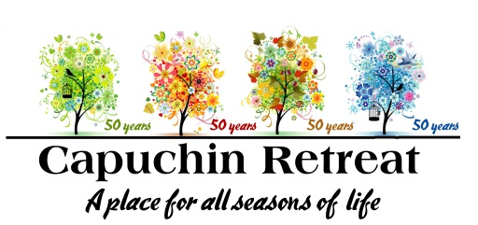
50th Anniversary Celebration Sponsorship Agreement
Sunday, July 15, 2018

Contact Name:
Company Name:
Address:
City: State Zip:
Phone: Email:
Please find my support below at one of the following levels:
☐ Platinum Love Sponsor - $25,000 ☐ Gold Faith Sponsor - $10,000
☐ Silver Hope Sponsor - $2,500 ☐ Bronze Grace Sponsor - $1,000

Name for inclusion on all 50th Anniversary Celebration Sponsorship Materials

☐ Enclosed is my payment in the amount of $
☐ Please send me an invoice for our sponsorship
☐ Pay Via Credit card

If you would prefer to pay by credit card (sorry, no American Express), please complete the following:
NAME: ____________________________________________________________________ AMOUNT: $_____________
CARD NUMBER: EXPIRATION DATE: / (Month/Year)
ADDRESS DIGITS (just the numbers, not the street name): ZIP CODE:
Phone # (in case of questions): ( )

PLEASE REMIT TO:
Linda Andrews, Administrator, Capuchin Retreat
62460 Mt. Vernon Rd, Washington, MI 48094
Phone: 248-651-4826 info@capretreat.org

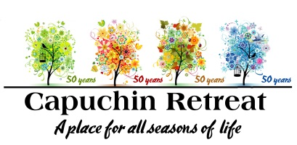

50th Anniversary Commemorative Book
Sunday, July 15, 2018
To purchase an advertisement in the book, please fill out this form and return it with your check
(payable to Capuchin Retreat) addressed to:
Capuchin Retreat
62460 Mt. Vernon Rd.
Washington, MI 48094

Company Name
Contact Person Phone
Address
City, State Zip ,
Contact Signature Date
(By signing this order, you assume full responsibility for editorial content of advertising submitted. Capuchin Retreat reserves the right to reject any and all advertising/message it deems inconsistent with its mission, in which case art work and payment will be returned to you.)
Please include the following in the Capuchin Retreat 50th Anniversary Commemorative Book:
- $5,000 Outside back cover (only one available, first received/first allowed - 4 color 8”x10”)
- $3,000 inside front cover (only one available, first received/first allowed – 4 color 8”x10”)
- $3,000 inside back cover (only one available, first received/first allowed – 4 color 8”x10”)
- $1000 Full Page ( 4 color 8”x 10”)
- $500 Half Page ( 4 color 8”x5”)
- $250 Quarter Page (4” x 5”)
- $50 Single Line “In Honor of” or “In Memory of”
(please print clearly as it should appear in book)
All ads must be in electronic format (300 dpi jpeg or high quality PDF), submitted to info@capretreat.org
If you would prefer to pay by credit card (sorry, no American Express), please complete the following:
NAME: ____________________________________________________________________ AMOUNT: $_____________
CARD NUMBER: EXPIRATION DATE: / (Month/Year)
ADDRESS DIGITS (just the numbers, not the street name): ZIP CODE:
Phone # (in case of questions): ( )

Due to printing deadlines, all materials must be submitted not later than June 15, 2018.
For questions, or more information, call 248 651-4826

50th Anniversary Celebration, July 15, 2018 Opportunities for Support & Recognition
$25,000 Platinum Love Sponsor:
- Logo recognition on signage at the event
- Reserved parking
- Invitation for two to Benefactor prayer service at Noon on July 15th
- Recognition on a Gold Benefactor Stone on our Franciscan Tree of Life in the front entryway
- Full page color ad in commemorative program book
- Recognition as a Platinum Love Sponsor in our fall printed newsletter, and our email update, reaching over 7,000 subscribers and our Facebook page reaching over 2,500 followers
- A “Thank You” listed in the commemorative program book
- Inclusion on commemorative 50th Anniversary benefactor plaque as a Platinum Love Sponsor to be displayed in the Retreat Center
$10,000 Gold Faith Sponsor:
- Reserved parking
- Invitation for two to Benefactor prayer service at Noon on July 15th
- Recognition on a Gold Dove on our Franciscan Tree of Life in the front entryway
- Half page color ad in commemorative program book
- Recognition as a Gold Faith Sponsor in our fall printed newsletter, and our email update, reaching over 7,000 subscribers and our Facebook page reaching over 2,500 followers
- A “Thank You” listed in the commemorative program book
- Inclusion on commemorative 50th Anniversary benefactor plaque as a Gold Faith Sponsor to be displayed in the Retreat Center
$2,500 Silver Hope Sponsor:
- Recognition on a Gold Leaf on our Franciscan Tree of Life in the front entryway
- Quarter page color ad in commemorative program book
- A “Thank You” listed in the commemorative program book
- Sponsorship recognition on the Capuchin Retreat website, and Facebook page reaching over 2,500 followers
- Inclusion on commemorative 50th Anniversary benefactor plaque as a Silver Hope Sponsor to be displayed in the Retreat Center
$1,000 Bronze Grace Sponsor:
- A “Thank You” listed in the commemorative program book
- Sponsorship recognition on the Capuchin Retreat website, and Facebook page reaching over 2,500 followers
- Inclusion on commemorative 50th Anniversary benefactor plaque as a Bronze Grace Sponsor to be displayed in the Retreat Center

For questions, or more information please contact:
Linda Andrews, Administrator, Capuchin Retreat
62460 Mt. Vernon Rd, Washington, MI 48094
Phone: 248-651-4826 info@capretreat.org

